C64 CHARSET-Adaptor/Switch Rev. 0

**Testing**

The module was tested on a C64 Mainboard ASSY250425. The test was conducted with various character sets, which were obtained from the internet. The character sets were selected by jumpering JP1.

The EPROM, which was used for the test was ST M27C512-10F1 (100ns).

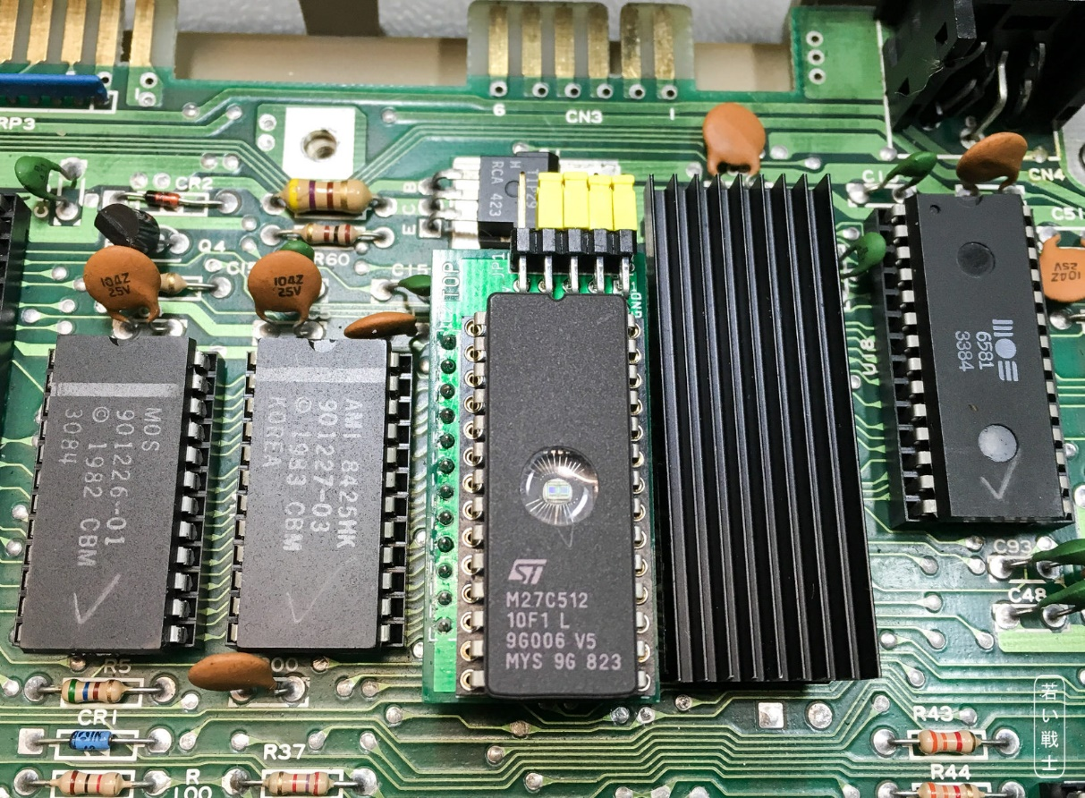

Figure 1: The module installed on an ASSY 250425 mainboard

It was required to slightly bend a capacitor away from the socket. Other than that, no collisions with other components have occurred. The module was sitting firmly in the socket.

After switching on the C64, the selected character sets worked properly. The selection was changed by modifying the jumpering of the pin header JP1.

Conclusion: The C64 CHARSET-Adaptor/Switch is fully functional.